INTRODUCTION TO CIECA’S ROAD SAFETY CHARTER WORK

By signing the European Road Safety Charter on April 6 2004, CIECA’s intention was to confirm its status as an active international association in the road safety field.

By committing itself to this process, our organisation has clearly shown its desire to participate in a concrete and effective way in the struggle to improve the safety of our roads, throughout the European Union and in our member countries.

We are aware that road safety improvements must involve a number of individuals and components : the quality of road infrastructure, vehicle manufacturing standards, development of road user legislation, the work of our police forces and knowledge of human behaviour. These are all different but complementary fields that need to be considered.

Amongst these factors, we cannot underestimate the importance of driver behaviour and its major role in road safety. Such behaviour is influenced by road safety education which is shaped by the driving licence test.

The driving test is an important step, but one which should be seen in the context of driver training spread out over time, from the cradle to the grave.

For this to happen, the driving test must be of a sufficient level to guarantee as far as possible that the driver will be careful, safe and respectful of other road users – including the most vulnerable ones, as well as the environment.

This is why CIECA decided to commit itself to improving the quality of the assessment of candidates, with the parallel aim of developing quality assurance for examiners.

These issues fully correspond with the activities carried out by our organisation. The quality of the driving test depends on the contents of the practical and theory components, the assessment criteria used, the quality of the examiners, recruitment requirements and initial and ongoing training. The application of quality processes at all levels by the driving testing organisations is also essential, from initial contact with the candidates to granting them a driving licence.

An important observation should be made at this point : there are currently too many differences between organisations and much work remains to be done in this area.

How, for example, can we scientifically explain :

⇨ the substantial differences in pass rates, from one country to another, in the theory test (from 30 to 82 %), and the practical test (from 46 to 94 %)?

⇨ the number of questions asked in the theory test (from 18 to 70) and the threshold required to pass (from 16 out of 18 to 52 out of 70)?

⇨ the length of the practical test (from 25 to 65 minutes)?

These figures, quoted from a 2005 study from the Institute of Applied Research into Childhood, Youth and Family of the University of Potsdam (Germany), underline the importance of greater harmonisation in the tests and of the application of quality systems in as many driver testing organisations as possible.

It is this path that CIECA has decided to follow, with a view to establishing a quality label scheme in which testing organisations can commit to internationally-defined quality standards.

In this way, by ensuring high quality tests, assessed by competent and well-trained examiners and managed by quality-driven structures, CIECA is convinced it can improve road safety.

A project group, composed of 10 CIECA member organisations, has worked hard on this subject in order to go beyond the current EU obligations laid down by EU Directive 2000/56. At the same time, it aims to remain sufficiently pragmatic to encourage the participation of the majority of CIECA members worldwide.

B. TRAFFIC SAFETY PREAMBLE: SHORT AND LONG-TERM GOALS FOR CIECA’S COMMITMENT TO THE ROAD SAFETY CHARTER

Our contribution to the Road Safety Charter commits CIECA to proceed further with its traffic safety work. This may be possible by enhancing the uniformity of the driving test at international level.

CIECA has adopted a fact-based approach, which means that its actions should be based on existing evidence where possible. This is why CIECA has been very actively involved in producing several international research reports concerning young driver training and testing (GADGET, DAN, ANDREA, ADVANCED, BASIC, TEST, NovEV). These reports clearly show how difficult it is to make comparisons between the national licensing systems. The national systems have their own history and culture, and their licensing systems are, of course, integrated into their respective societies. However, these reports tell us that a common research paradigm has been found to support an ideal licensing system. A good example of the concrete implementation of this research paradigm is the new Norwegian licensing model.

This ideal licensing system has been described from a traffic safety point of view, which means that the goal of the licensing process is traffic safety. According to the experts involved in the approach it should be especially effective among young male drivers. It could therefore serve as a theoretical framework for the RSC work too.

One problem is the big differences between national licensing systems. If one wants to both increase the uniformity of national driving tests and aim towards such a licensing ideal, it may be unrealistic to assume the work would be ready within the given time range. Another problem is limited resources, which forces the work to be done on a project basis. As in every project, it is necessary to remember that the longer the project lasts the greater the risks become. Therefore two goals have been set to guide the RSC-work:

1. Long-term vision: high quality product

The long-term vision of the RSC is to work towards a holistic licensing process where driver education, testing and overall road safety goals seamlessly interact.

This process refers to a holistic model, applying goals for pre-licensing initiatives and some instruments to improve traffic safety. It is, in a way, an ideal production model for driver licensing to produce traffic safety.

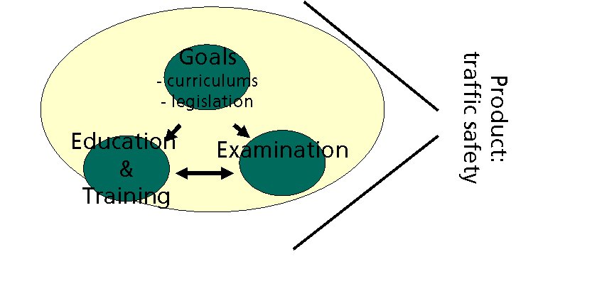
Figure 1. An illustration of a holistic traffic safety production model within licensing framework

The product goal challenges the test-centred way of thinking by offering a more complete approach instead. Driving practice and education are the main drivers to produce traffic safety in the holistic approach, not the driving test. The test then guides and controls the candidate’s learning process. Goals, legislation, regulations and plans are needed to structure the framework and to keep the system transparent.

The driving test’s assessment function is clear: the test assesses whether young drivers are able to show that they have learned certain minimum competencies. The extent to which the driving test should shape and guide road safety education is an issue that needs to be defined further and agreed among all countries. This may take time because some countries have more structured driving instruction systems than others. To be able to effectively utilize the holistic model, all the potential of driving instruction, driving practice and the driving test must be taken into account.

It is also important to observe that the holistic model may only offer a structure within which there are many ways to arrange the practical processes involved. In the long run, the uniformity of the processes concerned are important too, so it may be a good idea to start the work from the processes and then continue with the traffic safety production model.

2. Short-term goal: high quality processes

The short-term goal for the CIECA’s RSC-work is to harmonise the relevant high quality processes for the driving test.

a) A Quality Manual for Driver Testing Organisations

The prevailing research paradigm describes the ideal licensing system designed to produce traffic safety, but tells us little about the processes involved. Processes, however, remain an essential part of the CIECA’s Road Safety Charter work, when harmonising national countries’ driving test practises. To be able to work towards harmonisation, a reference benchmark for the test process must be defined.

Northern Ireland was one of the first CIECA member countries to obtain ISO quality certification for their driving test process. Their work is a good example of the high quality process descriptions for the driving test. Therefore it serves as a good basis for the RSC-project’s short-term goal.

At the beginning of the project, the focus was on administrative processes. The term “administrative” here must be read very broadly, since it includes all check functions that a driving test may have. It is especially important to try to harmonise the driving test criteria. Although the criteria has already been stated in the relevant EU Directive, it is well known that the variation in national practises is too large.

Another process that was focused on at the beginning of the RSC-work is customer service. Since the driving test has been traditionally carried out by national authorities in the absence of competition, fulfilling the needs of the customer has not always been the first priority. Nevertheless, it is clear that customers’ satisfaction is something that must be taken seriously and that must be defined in the testing processes from the outset.

b) Quality Assurance of Driving Examiners

A further short-term goal of the RSC-work is to improve the quality of driving examiners, with regard to access to the profession, initial training, testing and ongoing quality assurance. Much of this document mirrors the requirements laid down in the proposal for a 3rd EU driving licence directive. Important additions include statistical monitoring, more regular supervision, maintaining driving experience in the licence categories the examiner assesses, and regular medical check-ups.

c) Harmonisation of the Assessment Criteria

An initial goal of CIECA’s Road Safety Charter commitment was to work towards harmonising the criteria used to assess candidates during the driving test. As a first step towards this goal, the RSC working group have drafted a document which lists the various ‘competencies needed to pass the driving test’ and the ‘lack of competencies leading to failure’.

d) Quality of the Location of the Driving Test

This document was belatedly added to the RSC package: it lays down criteria for the location of the driving test, regardless of whether the test begins at a fixed place (i.e. driving test centre) or is geographically mobile. The importance of the location of the driving test was highlighted in CIECA’s TEST project.

This package of documents is designed to meet CIECA’s short-term goals, within the long-term objective of creating the ideal licensing process. This process should, for example, look into how the higher levels of the GDE matrix can be integrated into training and testing, and how the overall process can be more geared towards meeting road safety goals, not just process-oriented goals.

